**Tutorial on Tube Modelling**

1. The frequency response of a uniform tube is as given in the following equation. The length of the tube *l=17.5* cm and speed of sound *c=350m/s*. Draw the volume velocity vs. Frequency curve for first 4 root (b) What will be the bandwidth of each of the root if there is no energy loss



1. Verify that the reflection coefficient at any tube juncture in an acoustic tube model is bounded in magnitude by unity,
2. Consider an ideal lossless tube model for the production of vowels consisting of 2 sections as shown in the figure-4 below. Assume that the terminations at the glottis and lips are completely lossless. Derive the transfer function.

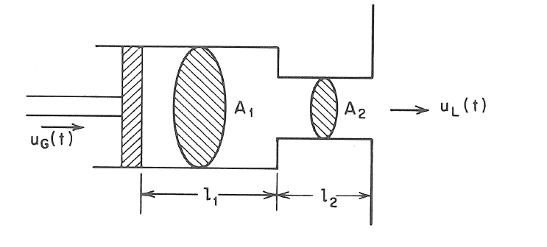

*Figure-4*

1. To produce a voiced speech signal of bandwidth 5 Khz how many section of lossless tubes are required. Where length of the tube is 17.5cm and c=35000cm/s. prove that one resonant frequency will be appear in every 1000Hz.